THEORY QUESTIONS
1.
(a)

The diagram below is used to demonstrate an activity in the laboratory.
Study it carefully and use it to answer the questions that follow:
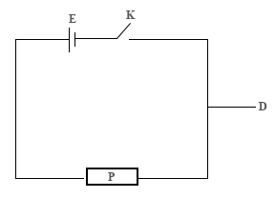
(i)

What does the diagram represent?
(ii)

Identify the components labelled, D, E, K and P in the diagram.
(iii)

State one function each of the parts labelled, D, E, K and P.
(iv)

Mention the energy transformation that occurs in E in the diagram when K is closed.
(b)

In an experiment, red and blue litmus papers were dipped separately into three test tubes containing one of the test substances listed in the table below.
Test substances | Observation |  | Conclusion
Test substances | Red litmus paper | Blue litmus paper | Conclusion
Lemon juice
Calcium hydroxide
Dilute hydrochloric acid
(i)

Copy and complete the table by making the necessary observation and conclusion for each substance.
(ii)

Name two of the test substances that would react with each other to produce salt and water.
(iii)

Write down a balanced chemical equation for the reaction in (ii) above.
(c)

The diagram below is an illustration of the human digestive system.
Study it carefully and use it to answer the questions that follow:
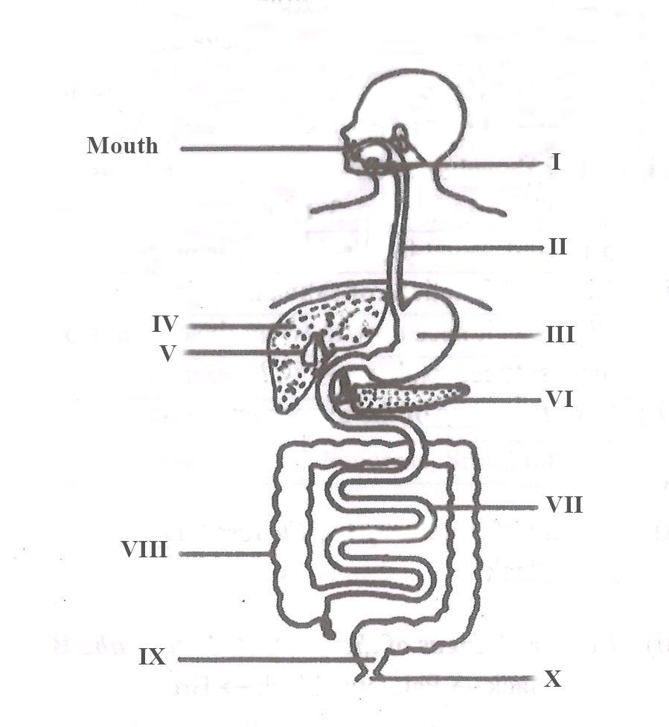
(i)

Name the parts labelled I, II, III and IV.
(ii)

State one function of each of the parts labelled V and VI.
(iii)

Name the part where the digestion of protein starts.
(iv)

Identify the part where
(α)

absorption of end-products of digestion takes place.
(β)

re-absorption of water takes place.
(γ)

egestion takes place.
(d)

The diagram below is an illustration of a simple farm tool.
Study it carefully and use it to answer the questions that follow:
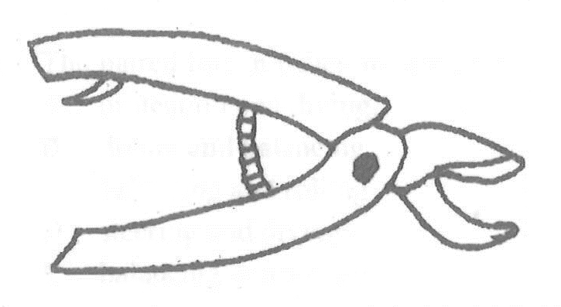
(i)

Identify the tool.
(ii)

State three uses of the tool.
(iii)

Mention three ways of maintaining the tool.

2.
(a)

(i)

What is neutralization reaction?
(ii)

Write a balanced chemical equation for the reaction between each of the following pairs of substances:
(α)

Sodium metal and dilute hydrochloric acid
(β)

Sodium hydroxide and dilute hydrochloric acid
(b)

Explain weaning as used in animal production.
(c)

(i)

What is a Milky Way?
(ii)

State one use of artificial satellites.
(d)

(i)

What is a habitat?
(ii)

Give two examples of a habitat.

3.
(a)

(i)

Define Pressure
(ii)

Explain why it is important to sharpen a knife before use.
(b)

(i)

State two differences between metals and non-metals.
(ii)

What is an alloy?
(ii)

Mention the components of each of the following alloys:
(α)

steel;
(β)

brass.
(c)

Mention three conditions suitable for rearing tilapia in a fishpond.
(d)

Explain how the streamlined body of a bony fish enables it to live successfully in water.

4.
(a)

(i)

What is a disease vector?
(ii)

Mention two methods of controlling each of the following types of pests of farm animals:
(α)

ectoparasites;
(β)

endoparasites.
(b)

(i)

State two symptoms of nitrogen deficiency in a tomato plant.
(ii)

Describe side dressing as a method of fertilizer application.
(c)

(i)

Define power
(ii)

State the S.I unit of power
(d)

Draw the electronic structure of potassium
[Atomic number of potassium = 19]

5.
(a)

(i)

What is respiration?
(ii)

Name the types of respiration that occur in humans.
(b)

List three ways of maintaining soil fertility.
(c)

(i)

Write the systematic name of each of the following chemical compounds:
(α)

FeS;
(β)

SO₂;
(γ)

CO₂.
(ii)

Give one reason why copper, silver and gold are mostly used in making ornaments and jewellery.
(d)

(i)

What is a fuse?
(ii)

Explain why a fuse is used in an electrical circuit.

6.
(a)

(i)

What is the difference between unicellular organism and multicellular organism?
(ii)

State two reasons why vegetable crops are important to humans.
(b)

(i)

State two elements of climate.
(ii)

What is the difference between climate and weather?
(c)

Mention three advantages of staking in crop production.
(d)

Explain each of the following processes:
(i)

corrosion;
(ii)

sublimation.

